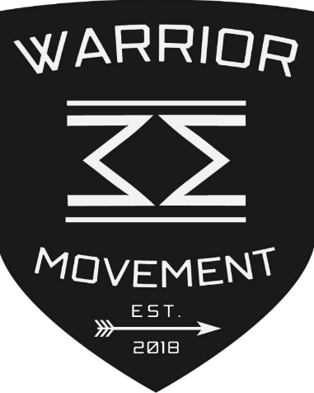

Warrior Movement
Together We Rise to battle against suicide
A 501(c)(3) non-profit organization

Tax ID # 83-0958791

Contribution Form

Donor Name (Mr/Mrs/Ms): ________________________________________________
Position & Corporation (if applicable): _______________________________________
Street address: ___________________________________________________________
City: ____________________ State _____________ Zip code: ____________________
Phone: ( )_________________ Email: _____________________________________

We would like to make a contribution as a:

Leading Donor ($2500 and above)
Sustaining Donor ($1000 to $2500)
Supporting Donor ($25 to $1000)
Would you allow us to list you on our website as a donor? In amount of: $______________

We would like to include some of our products for fundraising
We would like to contribute equipment

Is this contribution being made in memory or in honor of someone special? If so, please complete the following:
In memory of: ____________________ In honor of: _____________________

We are making this contribution by:
Cash
Check #______ Payable to: Warrior Movement
Credit card - Please visit: www.paypal.com/

Contributions to the WARRIOR MOVEMENT are tax-deductible.

The Warrior Movement is a non-profit public benefit 501(c)(3) corporation and is operated exclusively for educational and charitable purposes within the meaning of Section 501 (c)(3) of the Internal Revenue code. The Warrior Movement is not organized and shall not be operated for the private gain of any person. The property of the corporation is irrevocably dedicated to its educational and charitable purposes and no part of the receipts, or net earnings of the corporation shall be used for any activities other than its mission. The Warrior Movement will always retain control over the contributed funds and will provide the relative information regarding its activities on its website: www.jointhewarriormovement.com.

